TRAVEL TIPS FOR PHILIPPINES

Philippines are an archipelago of over 7,000 islands offers an extraordinary array of breathtaking natural scenery.
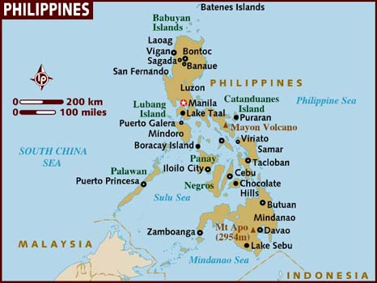

VISA The visa is to be obtained prior to arrival in the country

TIME:
Philippines is 2 ½ hrs ahead of Indian Standard Time.

GETTING THERE:
There are no direct flights to Manila from India, however, there are indirect flight to Manila such as Cathay Pacific, Malaysian Airlines, Singapore Airlines and Thai Airways..

GETTING AROUND:
In a country that is made up of over 7,100 islands and islets, travel has a lot to do with transportation. Rest assured that options are endless for getting around, some typical and others quite unique.

By Air
Manila, Cebu, Davao, Clark, Subic, and Laoag are the international gateways, with the Ninoy Aquino International Airport (NAIA) in Manila as the premier gateway. It is served by more than 30 airlines, which fly to different cities around the world. The Mactan International Airport (MIA) in Cebu handles regular flights from Japan, Singapore, and Australia as well as chartered flights from Hong Kong, the United States, and other major travel capitals. Davao International Airport handles regular flights from Indonesia and Singapore. The Diosdado Macapagal International Airport and Subic Airfield in Central Luzon service both chartered and cargo planes. Laoag International Airport in Ilocos Norte services regular flights from Taiwan and Macau.

Philippine Airlines (PAL), the national flag carrier and considered “Asia’s First Airline,” remains the country’s biggest airline company. It has the largest number of international flights to the Philippines as well as domestic flights. PAL links Manila to 14 cities in 8 countries, and flies regularly to 41 domestic destinations outside Manila.

Cebu Pacific Air (5J), the low fare leader in the Philippines, is the country's leading domestic airline with the lowest year-round fares, most number of destinations, most number of routes, most number of flights, most number of passengers flown in its domestic network and newest fleet of brand new Airbus A320s, Airbus A319s and ATR 72-100s. It links Manila to 21 domestic destinations and the Philippines to 12 international destinations with its direct flights. It also makes its international and domestic destinations virtually accessible to each other through its extensive connecting flight network. The airline currently operates hubs in Manila, Cebu, Davao and soon, in Clark.

Other airlines that presently fly the Philippine skies are Air Philippines, South East Asian Airlines, Laoag International Airlines, Asian Spirit Airlines, and Pacific Airways – each serving popular tourist destinations at pocket-easy prices. For a more personal experience, chartered flights are available via small air companies such as Airspan Corporation (helicopters), A. Soriano Aviation, and Aerolift Philippines (small-to-medium-sized planes).

By Sea
As the islands of the Philippines are separated by different bodies of water, the sea plays an integral part in travel. A range of seafarers are available, from huge cargo ships to small ferry boats; take long trips that last for a day or two with regular ship lines or take shorter ones with ferries. Major cruise liners call on the port of Manila.

WG&A Lines, a partnership between William Lines and the Aboitiz Group, has launched its SuperFerry Program, an affordable but convenient alternative to the usually crowded vessels of other ship lines.

By Land
Moving around the country by land is easy with national highways connecting the major islands and an extensive public transportation sytem, which includes the exotic Philippine jeepney. Trains, taxis, buses, jeepneys, and trikes are the main modes of public transportation. The calesa, a more elegant means of traveling in most major cities, is more commonly offered as a “fun ride” in many public parks across the country.

A land railway system operated by the Philippine National Railways, called the Metrotren, is recommended for long distance traveling. It reaches as far south as Carmona and Cavite, or as far north as Meycauayan, Bulacan. Within Metro Manila, the Light Railway Transit (LRT), which stretches from Caloocan to Baclaran, provides a fast alternative from the regular jeepney. The Metro Railway Transit (MRT) traverses the length of EDSA and connects North Avenue in Quezon City to Taft Avenue in Pasay City, passing through the major arteries of Makati's financial district.

Taxis provide the best means of transportation around the city, with a flag-down fare of PhP20 on the meter. For the steel-hearted, buses also tread the roads. A vast majority of city buses travel via Epifanio delos Santo Avenue (EDSA) while provincial bus lines have put up various terminals all across the country. The best means of short distance travel is the trike: the motorized version is called a tricycle, and the pedal-powered one is called a pedicab. Trike terminals are often found near a “palengke” or marketplace.

The undisputed “King of the Philippine Roads” is the jeepney. Since it first emerged after the Japanese occupation of the Philippines, it has become a fixture in roads all over the country – so much so that it is now considered a symbol of national pride. Jeepneys are adorned with colorful designs that distinguish them from one another, with themes ranging from the serious to the outright silly, but all uniquely Filipino.

CLIMATE
March to May is hot and dry. June to October is rainy, November to February is cool. Average temperatures: 25°C to 32°C; humidity is 77%.

LANGUAGES
Two official languages --- Filipino and English. Filipino which is based on Tagalog, is the national language. English is also widely used and is the medium of instruction in higher education.

ELECTRICITY
220 volts A/C is the common standard. 110 volts A/C is also used, especially in major hotels.

CURRENCY
The Philippines' monetary unit is the peso, divided into 100 centavos. Foreign currency may be exchanged at any hotels, most large department stores, banks, and authorized money changing shops accredited by the Central Bank of the Philippines.

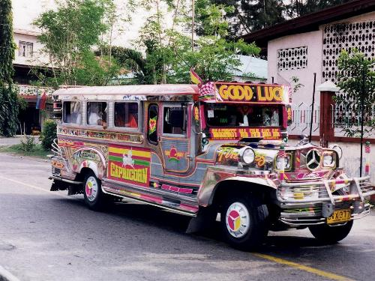
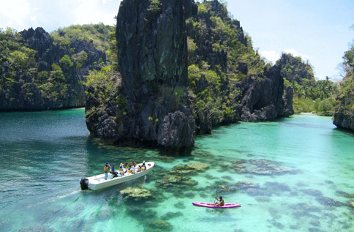

MAJOR SIGHTSEEING PLACES IN PHILIPPINES:

MANILA

The Philippines capital, though noisy and brash, has hidden charms that often surprise travellers who take the time to explore the metropolis. A curious mixture of old and new, Manila is a city of several parts and the closest Philippines gets to a cosmopolitan city.

•The business and corporate centre of Metro Manila is called Makati. This is where can be found the headquarters of multinational companies, the banks, the embassies and all the big names in business. The deluxe hotels here are all convenient to the main business and shopping areas.
•There is a second business area, which is farther north of Makati. This area may also come up with your corporate clients as located here are the Asian Development Bank, the Philippine Stock Exchange, the Centre for Research and Communication as well as some multinationals and banks. This area is called Ortigas, which is the name of its main street. Some people may refer to it as Mandaluyong.

To and from the airport
Manila Ninoy Aquino International Airport is located some 7km south of the city centre. The easiest way into the city is to take a cab. Once you've cleared customs you'll find plenty of taxi desks where you can pay a flat fare for a trip into the city (around PHP500 depending on exact destination). You'll be given a ticket, redeemable at the taxi desk outside. Failing that, you can catch an independent cab from outside, but unless you're really good at negotiating you're going to be ripped off. Owing to traffic congestion expect the journey to take at least 30 minutes even at relatively quiet times of day.

Jeepneys will take you to the nearest Light Rail station at Baclaran, from where you can catch the elevated railway into the city centre. A jeepney fare shouldn't be more than PHP10, usually depending on how many people are around. A single ticket on the Metro Rail costs PHP12 to central stations such as Pedro Gil in Malate or UN Avenue in Ermita.

GETTING AROUND

Light and Metro Rail
Manila's modern public transport network comprises of the elevated rail network that snakes across the city. It consists of two distinct lines, the LRT running from north to south across the city with stations at all principal points in between, and the MRT, which runs the length of the city. The Light Rail network costs PHP12 per ride, while the more modern MRT costs PHP10-15 depending on the destination. You have to pay the fare for the other line if you interchange from a different journey. It's worth purchasing the Flash Pass Card which allows multiple rides on all metro lines. It costs PHP250 and can be used for a week.

Bus
Buses are operated by numerous private companies throughout the Manila Metro area. They come in various colours and sizes, but are generally run down and crowded. Competition is also fierce. The flip-side is that they're extremely cheap, you should only pay PHP1 for a short hop, although you might be asked for more. Destinations are usually printed in English on signs that the conductor will hold up at stops, or shout at as the bus nears.

More salubrious-looking buses do run to scheduled routes around the city, but at PHP10 per trip, if your destination is anywhere near the Metro Rail station, you're better off getting the train.

Taxi
Taxis are abundant but it's recommended that you familiarise the route before leaving your hotel or pension house. Available at bookstores and newsstands is a relatively easy-to-understand map called EZ Map. It's a good idea to memorise street names: this is your safeguard against unscrupulous taxi drivers who try and extend the trip for added revenue. Flag down rate is PHP25 (USD0.50) plus PHP2 for every 100 metres. Taxi drivers don't give change.

Colourful jeepneys (refurbished American army jeeps) are abundant in Manila. This is the common man's vehicle of choice. Check for routes with a local. If you get lost, ask directions from traffic enforcers or shop owners. Jeepney fares are typically PHP4-5 one way, although as a tourist you may be asked for up to twice as much. Jeepneys have their destination painted on them, but it can be hard to decipher so it might be advisable to ask. If you want to catch one, wave your hand and it will pull over. You climb in the back, and, if crowded, hand your money along to the front. To make the driver stop shout out "para" and the jeepney will pull in, although make sure you're ready to disembark rapidly, as jeepneys hardly ever come to a complete stop.

MUST SEES

Intramuros

Once the political and economic centre of the city during the Spanish regime (1571-1898), the walled city of Intramuros has been refurbished and converted. It now stands as a refined old town filled with entertainment and attractions. Old prison chambers intact with iron railings are now occupied by restaurants, bars, art galleries and souvenir shops.

Horse-drawn carriages with cocheros (coachmen) well-versed in the city's history can easily be contracted for quick tours. Just PHP250 (or around USD5) will buy you an hour's worth of moving from one historic spot to another, passing ramparts, museums and churches as well as lush gardens, warehouses and even torture chambers.

Most poignant is the memorial marking the death of 10,000 non-combatants (women and children) during the bombing of Manila in World War Two. You should make the effort to see the unique baroque San Agustin Church and its small museum as well as Fort Santiago.
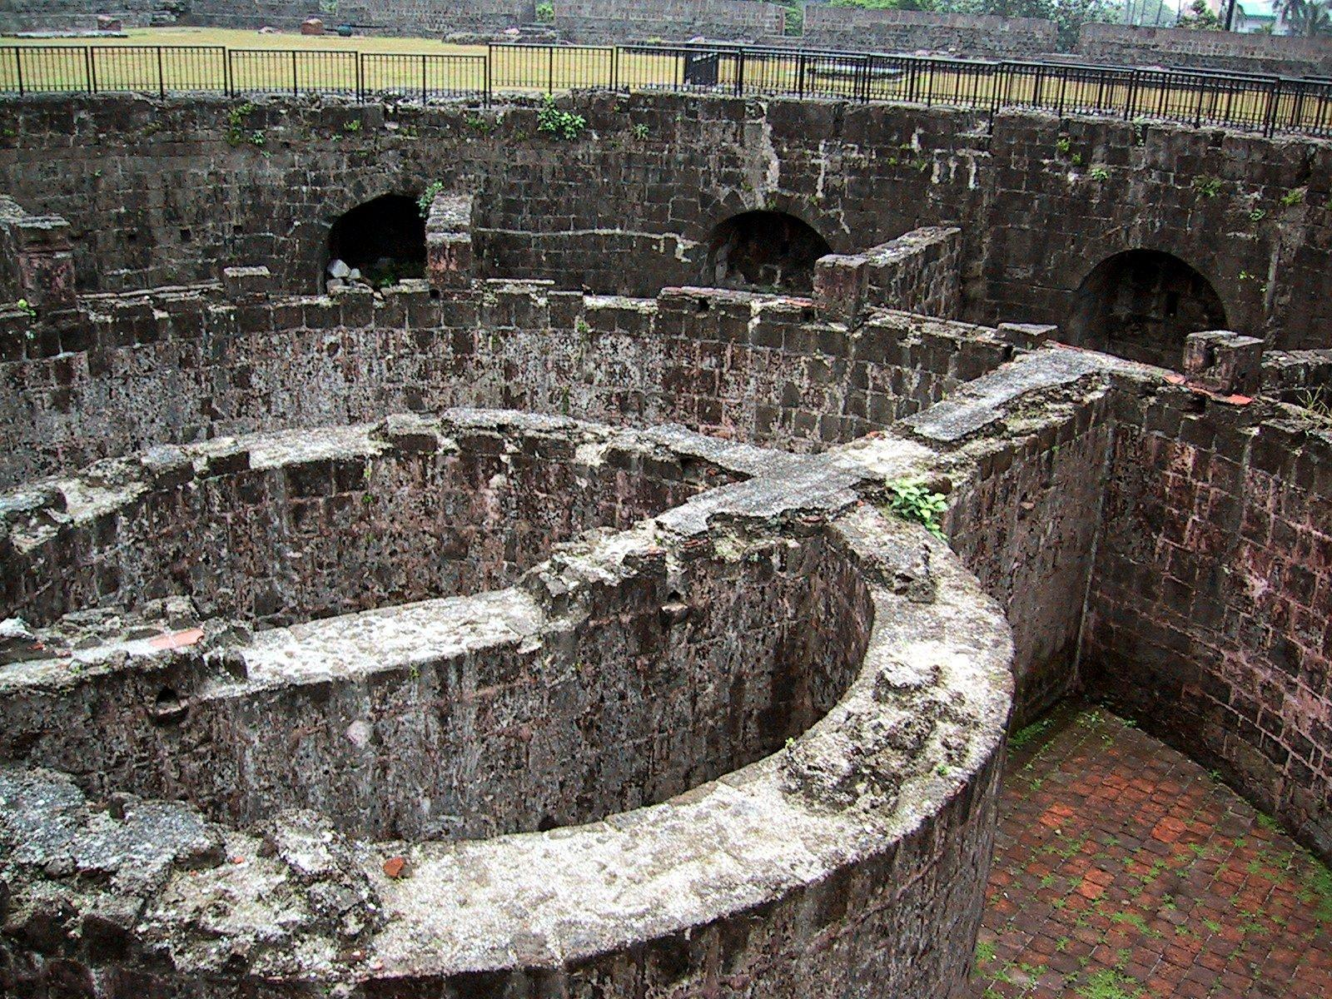
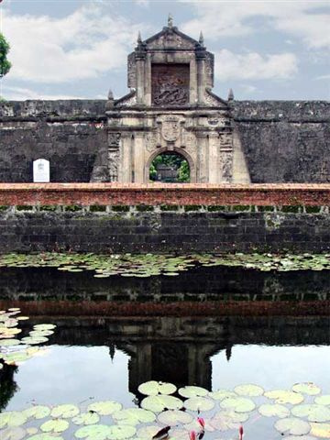

Fort Santiago

It's the most fascinating relic in the Intramuros and a must-see. This fort was built over 400 years ago and has had a role to play in almost every significant event since then. It was originally the home of the last Filipino king before the Spanish usurpers invaded, replacing the wooden structure with a stone stronghold at the mouth of the river. The British used it during their occupancy and in 1896 the Spanish incarcerated José Rizal here. At the park's centre is a small shrine to the revolutionary, which contains some of his relics and samples of his writing. Footsteps on the floor around the garden allow you re-enact Rizal's final steps to "martyrdom".

The fort was most notoriously used as a wartime prison by the Japanese, and according to some of the more gruesome stories American soldiers and Filipino guerillas were tortured and executed here. Plaques mark mass graves where hundreds of bodies were found following the war. Interestingly the fort was also one of hundreds of sites on the islands where the Japanese hid their war wealth, huge amounts of gold bullion valued at billions of dollars.

Rizal Park

Rizal Park is the city's largest open space, and is a pleasant place to stroll. There isn't a great deal to do here except relax among the formal gardens - the Japanese and Chinese gardens are particularly beautiful - and idle away the day. Locals flock here on the weekend, and on Sundays there is usually some form of entertainment, either impromptu music from buskers or scheduled concerts at the park's auditorium. The park is named after the Filipino revolutionary hero Dr José Rizal, who was executed here by the Spanish in 1896. The bronze statue in the middle of the park is of him. If you come here early in the morning you'll find locals going through their Tai Chi routines.

Corregidor Island

Right at the entrance of Manila Bay is tiny Corregidor Island where joint Filipino and American forces made their last stand against the invading Japanese Imperial Army during the second World War. On the island you can still see the gigantic sea-facing guns and the barracks. Here also, it's rumoured, that war treasure was buried but most people view the island as a war grave. The memorials are a poignant reminder of the bravery shown by people on all sides and the fallen.

A typical tour will look at the gun positions and the Malinta tunnel network, where general MacArthur's headquarters stood against Japanese bombardment. Elsewhere on the island you can see relics of Spanish colonial rule although much of it's overgrown and left to the jungle. A population of bold-as-brass monkeys now inhabit the place and have no inhibitions when it comes to approaching visitors.

The island is an hour and a half from Manila Bay on ferry from the pier at the Cultural Centre (Roxas Boulevard). Sun Cruises operates guided tours of the islands, including ferry transfers. A day-tour starts from PHP1,690 approximately.

CEBU

In the Visayas group, the first island to be colonised by the Spaniards is also home to the oldest city in the country, Cebu City, and acts as the gateway to the Central and Southern Philippines.

GETTING THERE:

To and from the airport
Cebu International Airport is situated on Mactan Island, approximately 15km east of the city, just outside Lapu-Lapu City (the main town on Mactan).

By Bus
There is no scheduled bus service to the city, although some of the hotels will provide complimentary shuttle services for arriving passengers - ask when you make your booking.

By Taxis
Taxis are available either from the counters in the arrivals hall or from the rank outside. If you pre-book a car to meet you on arrival expect to pay around PHP200 (USD4) or up to PHP500 (USD10) for a mini-bus into Cebu City centre. Fares may vary depending on exact destination. You may have to agree a price with your driver before getting in - aim for around PHP150.

GETTING AROUND:

Public Transportation

The main form of public transport in the city and all over the island is the ubiquitous and unmissable jeepneys. These brightly coloured vehicles first introduced to the Philippines during the Second World War are adapted long wheel based jeeps, similar in shape to American school buses. They are customised by their owners with bull-bars, mirrors, stickers and lights to produce something that would look more at home in a fairground.

Jeepneys carry up to around 20 passengers each, although drivers like to pack on as many as possible, and run on designated routes with stops for boarding. Alighting is on request, people either call out or bang on the roof to warn the driver to stop. Destinations are marked as towns or areas of a city and buses are numbered, but it still takes some time to familiarise yourself with jeepney routes, ask at your hotel for initial guidance on getting started. Once on board the habitual friendliness of the Filipinos means plenty of extra advice in your travels should you need it. Fares are paid to the driver or assistant - a one-way trip is PHP4. On crowded jeepneys this is sometimes passed forwards from passenger to passenger so don't be surprised if someone hands you money - simply hand it on.

Buses

For destinations around Cebu leave from the Northern and Southern bus terminals (for destinations in their respective directions). The Southern bus terminal (for Talisay, San Fernando, Moalboal, Badian etc.) is located on Rizal Ave, near to the Elizabeth Mall. The Northern bus terminal (Carmen, Sogod, Bogo etc.) is on MJ Cuenco Ave, near to the SM City Mall. Numerous operators offer services and the standards of vehicle vary somewhat. You should note that driving in the Philippines is uniformly reckless, and that applies to buses as well as private vehicles. Generally speaking the more ramshackle the vehicle and the cheaper the ticket, the more reckless the drive. Several people each year are killed and many more injured in bus related incidents on the islands, so saving a few pesos could cost you a lot more. If you have any doubts about the state of the vehicle, don't board. Fares are very reasonable, from PHP80-PHP120.

Taxis

Taxis are widely available throughout the city. Cabs are all metered and drivers will usually switch the meter on without needing to be prompted to do so. The ones that won't don't put up much argument if you insist. A ride across town shouldn't cost more than around PHP80-100.

Ferries

Cebu Island is a hub for ferry services to all outlying islands in the Visayas and beyond. From the city docks you can catch ferry services to islands including Bohol, Camotes, Olango Cabilao and many others. For Bantayan and Negros you would be better advised to travel by land to the north and west coasts. Ferries for Negros leave from most major towns along the west coast. For Bantayan catch the ferry from Hagnaya. For all ferries from the city check the sailing times in the local press or ask at the tourist information centre. Boats land and depart from the Southern Docks and piers along Quezon Boulevard.

MUST SEES:

Fort San Pedro

Fort San Pedro was the first stronghold of Spanish colonialism in the country, founded in 1565 by the famed conquistador Miguel Lopez de Legaspi. It was built to defend the fledgling trading port from local pirates and resistant tribes. Although it took a couple of centuries to fully complete the triangular construction, its three-metre-thick walls proved so formidable a defence that its structure remained unchanged right up to 1898, when the Spanish left.

The government restored the fort in the late 1950s, planting the inside as a public garden - now a lush green park. The bastion walls are largely intact, and there are several cannons from Spanish times still in their places pointing out to sea. A collection of items from the National Museum is housed in the small white-walled building just inside the fort entrance. Within you can see a range of artefacts from the fort's past as well as other displays.

Open: 0700 hrs – 2300 hrs

Magellan's Cross

On April 21, 1521 the first Catholic Filipinos were baptised in Cebu by Father Pedro Valderrama of the Magellan expedition. To commemorate the event Magellan himself had a wooden cross planted at the spot. Just six days later, of course, Magellan was killed on Mactan, but the cross still stands as a reminder of the influence the great explorer had on the history of Cebu.

As the weather and souvenir hunters took their collective toll the original cross was covered with a larger wooden cross in order to preserve it, so what you see isn't exactly what Magellan planted. But it is still claimed that the present cross contains the original wood and is considered the defining symbol of Cebu. The cross is housed in a small rotunda near to the city hall, the mural on the interior of the dome depicts Magellan and his crew erecting the cross.
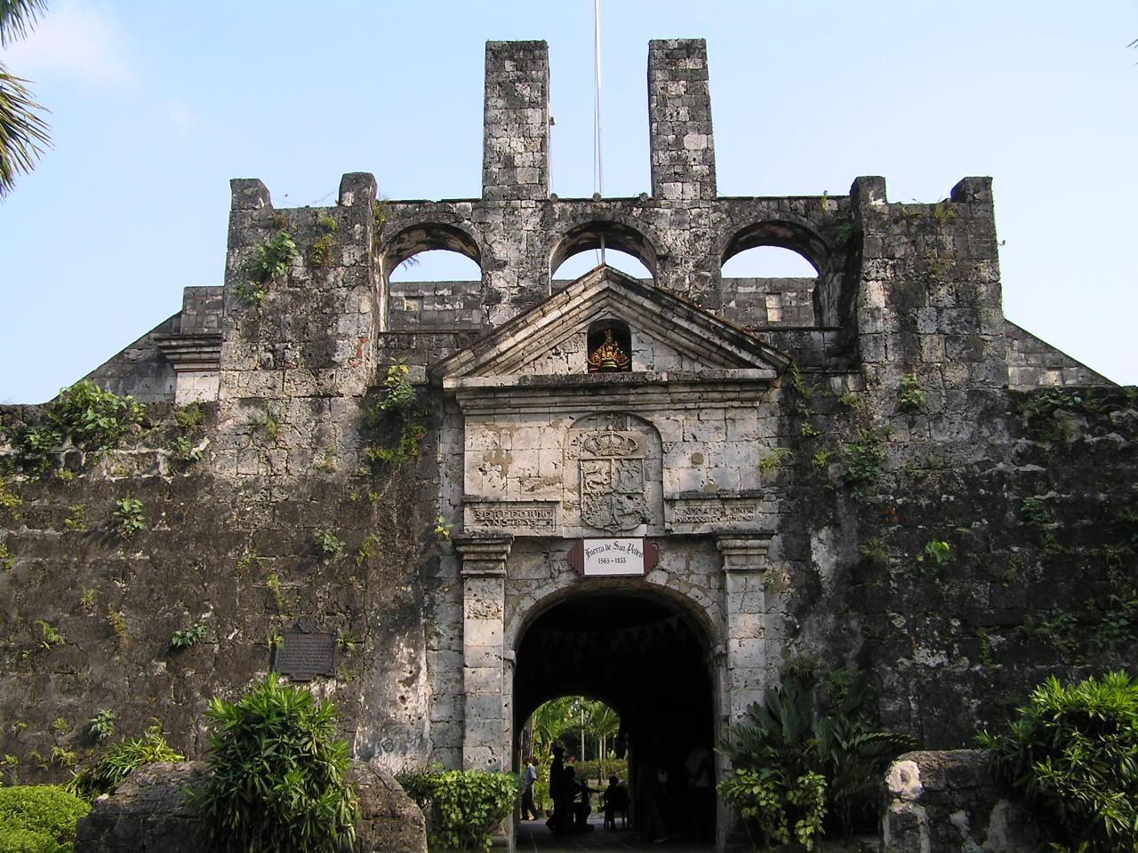
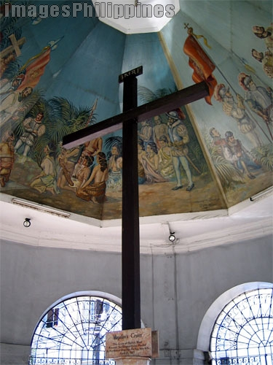

Casa Gorordo Museum
35 Lopez Jaena St.

A short distance north from the old town attractions is the Gorordo House, one of the last remaining late-19th-century town houses that stood here in the Parian District - the erstwhile homes of the city's wealthiest traders and merchants of the day. It was originally owned by the influential Gorordo family and was once the home of Bishop Juan Gorordo, the first Filipino archbishop of the province.

Bought as a museum in the 1980s the house has since been restored in period style. Everyday domestic items tell the story of life as a wealthy citizen of Cebu at the turn of the century, while photographs of the city show its modernisation through the last half of the 19th century and into the 20th century. The house's ecclesiastical heritage is evident in the prevalence of religious paintings, statues and icons that are on display. Temporary exhibits are sometimes hosted here.

Open: Mon - Sat 0900 hrs – 1200 hrs & 1400 hrs – 1800 hrs

Magellan's Marker and Lapu-Lapu
Punta Engaño, Mactan Island

Ferdinand Magellan, one of the pioneers of the European great age of discovery, met his rather undignified end on the shore of Mactan Island, today joined to the mainland by a bridge. What happened to the explorer's body is open to some conjecture. Although his crew claimed to have given their captain a Viking burial, setting his ship on fire with his body on board, local legend relates that Lapu-Lapu either kept his conquered adversary's body (despite being offered much wealth for its return by the Spanish sailors) or that the unfortunate Portuguese was so completely battered that there was nothing recognisable left of him.

In the 19th century the Europeans erected a marker where Magellan fell at Punta Engaño. Understandably not wanting their hero to be upstaged, even posthumously, the Filipinos built a bronze statue of Lapu-Lapu in the same place, depicting their hero brandishing the traditional weaponry of a bola and club. It's appropriate enough as that would have been about the last thing Magellan saw.

Basilica Minore Del Santo Niño

This Catholic basilica is regarded by locals as the holiest site in the Philippines, as it was on this spot that the islands were first officially "Christianised". Following Hamuban's baptism in 1521 at the hands of Magellan's priest, Magellan presented Queen Juana with a statue of the infant Jesus (the Santo Niño). Lost for some years the statue was discovered by Legaspi when the conquistador arrived in Cebu 40 years later. Legaspi was responsible for the building of the basilica (originally called the San Agustin Church), and displayed the icon as a holy relic.

The original wooden church burned down soon after first being built and was subsequently rebuilt several times following fires, although its relic survived each time. The current church is built from coral and dates from 1740. The advent of Christianity in the Philippines is dated from the finding of the Santo Niño image, and in 1965, to commemorate the fourth centennial of Christianity in the nation, the church was proclaimed the Basilica Minore del Santo Niño. Mass is still celebrated here with large events held in the outside auditorium. The statue is the focus of many Filipino pilgrims from all over the archipelago, and during key dates in the Christian calendar the church is packed. If prepared to put up with the jostling of the devout you can pay your respects to the statue in its gilded tabernacle next to the altar.

Taoist Temple

A popular little excursion to the edge of the city proper brings you to the Taoist Temple. Built in traditional Oriental style the temple preserves the philosophy of Lao Tse, a Chinese thinker from well over 2,000 years ago. It obviously still has relevance as many of the well-heeled locals come here to have their fortunes told by the monks.

It's not necessary to believe in Taoist philosophy to enjoy a trip here; in the upmarket Beverly Hills district, you get some stunning views over downtown Cebu. Penitents and believers climb 99 steps to the temple, and the air is redolent with the heady smell of incense. Inside the complex you'll find Oriental paraphernalia including a towering gilded dragon in typically brightly painted colours. Taoist ceremonies are held on Sundays. Take a taxi to the temple, it's several kilometres from the city.

PALAWAN

In many ways the country's final frontier, Palawan is an island of astounding natural beauty in the west of the Philippines. The south of the island in particular is home to almost unexplored lush forest, rivers and waterfalls still only accessible to more adventurous travellers.

There are parts of the island that are more easily visited, however, such as the pretty town of El Nido, dramatically positioned in a north-western bay surrounded by soaring limestone cliffs where swallows make their nests (which are collected and used in Chinese restaurants for bird's nest soup). The charming town has a few guesthouses, but is otherwise untainted by tourism and makes an ideal jumping off point for visiting the numerous beautiful islands of the Bacuit Archipelago.

Many visitors to Palawan come to see the 7km-long underground river near St Paul's Bay, which can be reached by boat from Baheli. The trip through the long, dark cave by torch is a real adventure, made all the more atmospheric by the resident bats flying around.

Palawan has become a famous diving spot, the best place for which is the amazing expanse of reef called Tubbataha between Palawan and Mindanao. This enormous reef (332 sq km) attracts increasing numbers of divers who come to swim with sharks and stingrays amidst soft coral gardens. Dive tour operators in Cebu and Manila arrange trips to Tubbataha.

DAVAO

The Philippines' second city is a fascinating and culturally diverse melting pot of people that has much to offer visitors. Davao is the main port and economic centre for Mindanao Island and the Southern Philippines; it is also both the perfect gateway city to the region's other attractions and an intoxicating destination in its own right.

In terms of area, Davao is one of the world's largest cities, occupying some 2,212 sq km. By comparison New York City occupies a paltry 787 sq km. However with a population that only recently exceeded a million people, Davao has a relaxed and spacious feel to it.

Davao is the main gateway for Mount Apo, at 2,954m the highest peak in the Philippines. The surrounding national park has some truly awesome hiking on offer, and is home to some rare fauna and flora including the world's largest species of orchid.

Local beaches are generally excellent while the restaurant and nightlife scene is very lively. Davao is also popular with shoppers who come here for the legendary New Year sales and for the abundant high quality ethnic handicrafts.

BANAUE RICE TERRACES

Classified by UNESCO as a world heritage site and often quoted as a major contender to be the eighth wonder of the world, the Banaue Rice Terraces in the Northern Philippines are a truly breathtaking spectacle.

At an elevation of over 1,200m, the deftly created terraces stretch for miles, creating a lush, green landscape of giant steps. Hand-carved into the mountainside over a period of 2,000 years, this amazing feat of engineering is still tilled by local tribes using primitive tools much like those of their forefathers. If laid from end-to-end, the terraces would stretch halfway across the world - quite an achievement for what are basically rice paddies.

The area around Banaue is interesting, with the local Ilfugao tribal villages providing a fascinating insight into this ancient culture, though simply walking around the terraces themselves is enough for many.

MALAPASCUA ISLAND

Fast catching up with Boracay as the island to go to, Malapascua offers pretty much everything you could ask for from a beach holiday: wide expanses of white sand, friendly locals, and snorkelling spots just a few metres from shore.

The small island just off Cebu has yet to become a fixture on the package tour itinerary, though, so you can still get away from it all without bumping into hordes of tourists. Still mainly a backpackers' haunt, accommodation is generally relatively simple, though more upmarket places are on the increase and tourism may well explode in the next few years.

Though fairly low key, the island is lively with a pretty good choice of restaurants and bars, while still retaining an authentic feel, appealing to foreign travellers as well as domestic tourists.

CHOCOLATE HILLS

Imagine a thousand grassy limestone hills that, in the dry season, look like giant scoops of chocolate ice-cream. This geological wonder has - as yet - managed to defy rational explanation and has inspired numerous fanciful legends involving giants engaging in mud fights or crying for their lost love.

The other-wordly landscape of the Chocolate Hills is the main draw to the island of Bohol in the Visayas, but there are also some excellent beaches nearby as well as a number of attractive old churches.

The island's other main claim to fame is that it is home to the world's smallest monkey, the insect-eating tarsier. No bigger than the palm of your hand, this bizarre-looking creature with enormous eyes is believed to date back to prehistoric times. They are notoriously shy, though, rendering them difficult to spot.

TAAL VOLCANO AND LAKE

On the island of Luzon, within easy reach of Manila, Taal volcano is something of an oddity in that its crater is filled with a lake, in which there is a small island containing its own crater lake.

The volcano is very much active, having erupted over 30 times since the 16th century. The last major eruption was in 1965, and seismologists believe that there may be another brewing in the near future. The smallest volcano in the world is a truly amazing sight where you can see two smaller lakes of hot water, one green and the other almost red. There is also a gas vent and in the middle of it all, a triangular obelisk of hard rock.

Trekking is possible to the lake, where you can swim - the outer lake is fresh water, though the inner one is a diluted form of sulphuric acid and therefore not recommended for extended bathing.

BANTAYAN

If you want to get away from tourist crowds, Bantayan Island in the Visayas is the place to head for.

The Philippines' oldest Catholic parish is home to centuries-old stone churches and forts made of coral stone bound together with egg white. Eggs are not in short supply here -1.4 million are produced each day, making the island the country's egg basket.

The island's chief draw, though, is its powdery, white sand beaches unmarred by the practice of dynamite fishing that has had devastating effects on the coral reefs around many of the islands. Conservation efforts by island resident and international environmental lawyer Tony Oposa have resulted in the establishment of marine sanctuaries all over the island, making it a perfect place for nature-lovers and beach babes alike.

BORACAY

The leading party isle in the archipelago, Boracay has developed a reputation for being a hedonistic paradise where people come for a good time in the sun.

The island earned its fame initially due to its beautiful beaches, regularly cited as some of the best in the world - and you certainly won't be disappointed with the soft white sand surrounding the island. There's certainly plenty to keep you entertained here after nightfall too - local entrepreneurs haven't been slow at realising how much potential tourist cash there is to be had and there is an inordinate number of bars and clubs to keep the most party-frenzied visitor dancing till dawn.

The island is rapidly being taken over by tourism, though, so although a great place to come and enjoy the sun, don't expect to see a typical slice of Filipino life in Boracay.

LIST OF INDIAN RESTAURANTS IN PHILIPPINES:

- Pahar Indian
Boat Station 3, Ambulong Boracay Island,
Malay Aklan Philippines
Ph: 288 5156

- Govinda Vegetarian
26 Sanchiangko St Cebu
Philippines

- Swagat Indian
119 Rada st.,
Legaspi vill Makati
1232 Philippines
Ph: 27525669

- Al Shahs
Ground Floor, Traveller's Inn Condominium,
7880 Makati Ave Makati City
Philippines
Ph: 85 93 50

- Kashmir
5354 Chilean Bldg
cor Gen Luna St Makati City
Philippines
Ph: 8444924 / 8968721 / 8993205

- Kashmir Pasay
816 Pasay Rd
Makati City
Philippines
Ph: 8444927, 8444924

- New Bombay
Stall 202, Buendia Shopping Plaza
Gil Puyat Ave Makati City
Philippines
Ph: 8937506, 8944176

- Queens Manila
146-B, Jupiter St Makati City
1209 Philippines
Ph: 02 8951316

- Spices
The Peninsula Manila Cor of Ayala and Makati Aves
Makati City
Philippines
Ph: 8103456, 8123456

- Ghazal
1551 A Mabini St,
Ermita Manila
Philippines
Ph: 02 521 1996

- Kashmir
Merchant Center
523 Padre Faura,
Ermita Manila
Philippines
Ph: 523 1521

- Raj Modern
1820 Ma Orosa St Malate
Manila Philippines
Ph: 525 4858

- Petes Curry House
Supermarket Complex,
Between Montevideo and Monteclair St,
Merville Park Subd Paranaque City
Philippines

